Title: | AEP QRO.  Window Lifter
Authors: Habib Alejandro Apez González.
Estefanía López Villagómez.

History
Issue status  (Index) | Maturity/Date  (draft/invalid/valid)  (dd-mmm-yyyy) | Author  Department | Check/Release  Department | Description
5.0 | Draft  28-0ct-17 | Habib Alejandro  Apez González.  Estefanía  López Villagómez. | Continental Engineers. | Window Lifter is a project than simulates the behavior of an operational car window.  This one shall do the up and down movement of the window at the user will prefer with the use of a simple interface based in some buttons and a light system to show us the action.

Table of Contents
1 Purpose 4
2 Definitions and abbreviations 4
2.1 Definitions 4
2.2 Abbreviations 4
2.3 References 5
3 Realization constraints and targets 5
4 SW Conceptual design 5
4.1 Window Lifter Block Diagram 6
4.2 Window Lifter Implementation 6
5 SW Component internal breakdown 7
5.1 Up Normal 7
5.2 Down Normal 7
5.3 One Touch Up 8
5.4 One Touch Down 8
5.5 Antipinch 9
5.6 Functional Decomposition 9
6 Function Description and Dynamic Behavior 13
6.1 HAL 13
6.1.1 Button.c 13
6.1.2 Clock 18
6.1.3 Leds 19
6.1.4 Segmentbar 23
6.1.5 Timer 27
6.2 APP 31
6.2.1 Windowlifter 31

Purpose

A power window lifter is an automobile part which can be manipulated to up or down and other specific safety use control.

This project will work using two push buttons, one for the up movement, and the other one to down, these specific buttons are going to order to our product to simulate the window movement represented with a ten segment red light bar, this light will turn on to be a complete close window or turn off to get down as the user will wanted.

Each button have two modes, normal and one touch. The first one works to make all the track if you press for determinate time, and the second one is for only a part of the track with a quick movement.

There is to an extra function: Anti pinch this is a safety requirement than works only when the up movement is activated to prevent some kind of accidents, this stops the other move and make than our window down completely and remain stop for 5 seconds. Then our normal process continues.

The process our all the functions are scheduled in layers: MAL, HAL, APP. To simplify the final operations and delimit the functions with the option to continue adding other future operations.

Definitions and abbreviations

Definitions

MCAL | Microcontroller Abstraction Layer
HAL | Hardware Abstraction Layer
APP | Application Layer
SW | Software
HW | Hardware
GPIO | General Purpose Input/Output
LPIT | Low Power Interrupt Timer

Abbreviations

s | Second
ms | Milisecond

References
N° | Document name | Reference
1 | Window lifter requirements.docx | Continental
2 | V_Cycle Process | Continental
3 | V_Cycle Process Script.xlsx | Continental
4 | S32K1xx Series Reference Manual | NXP
5 | Naming Conventions.pdf | Continental
6 | https://www.iar.com/iar-embedded-workbench | IAR
7 | MISRA C:2012 March 2013 | Continental
8 | S32K1xx Data sheet | NXP

Realization constraints and targets

Window Lifter

The principal purpose is controlling a simulation window movement.

It will going to work with the interface of 3 different buttons, one will do the action to up, the other one will do the down and an extra will do the Antipinch mode.

There is going to be appreciable de action using a light to indicate it, blue to Up, Green to Down.

One restriction of the requirements is than this project only can have a ten segment bar led to simulate the movement.

Other restriction is the use of the board S32K144EVB-Q100.

SW Conceptual design

General window lifter system, it specifies the actions of the application with the interaction of the buttons and the corresponding light to the action they will going to do: Up, Down and Antipinch, to can make than the window shows.

Window Lifter Block Diagram
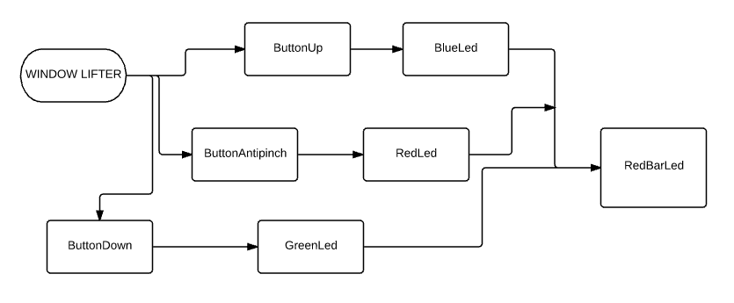

Window Lifter Implementation

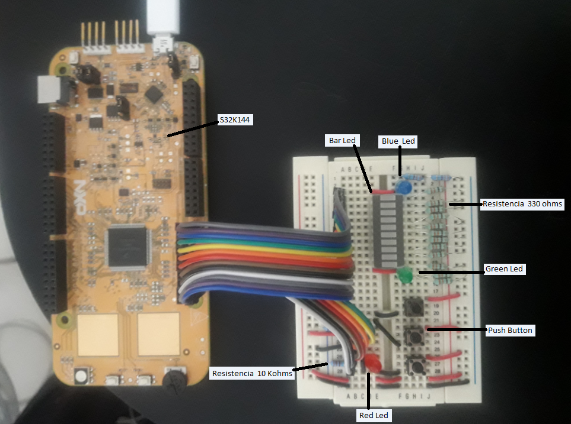

SW Component internal breakdown
In this section, the main functions in APP are described through a block diagrams. Each diagram shows the relation between that component and other components located in HAL and MCAL.

Up Normal

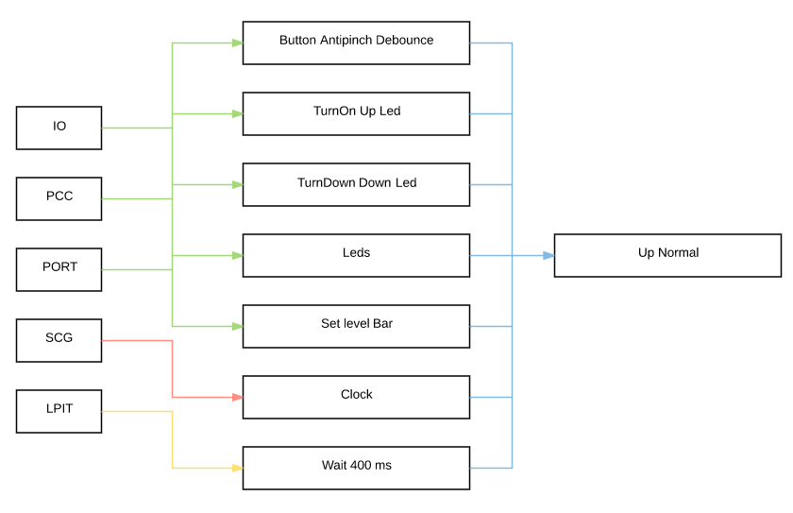

Down Normal

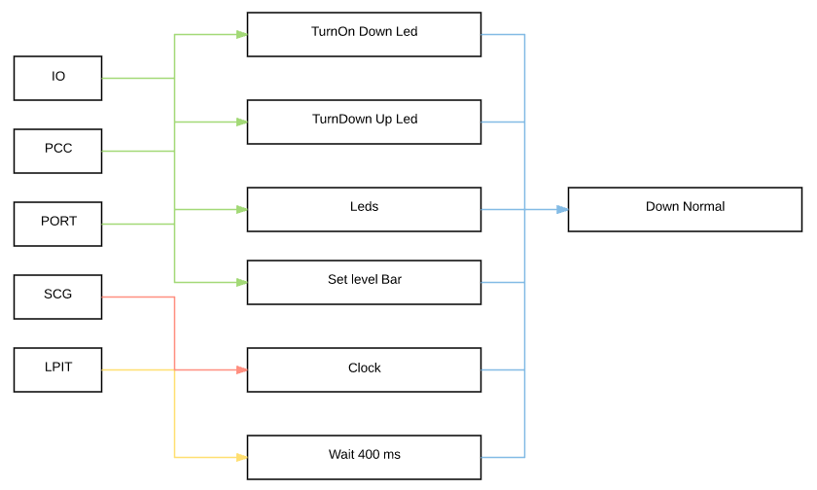

One Touch Up
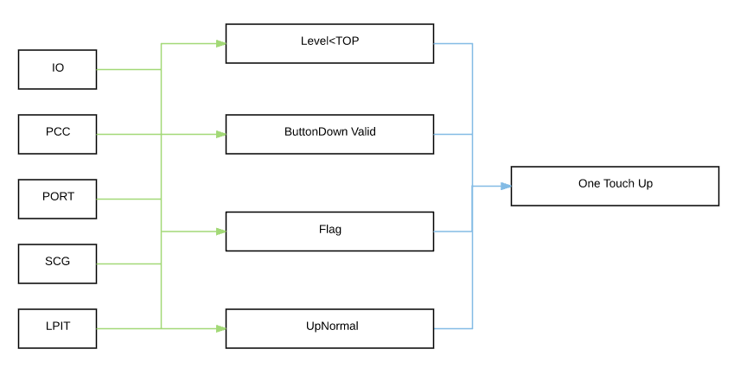

One Touch Down

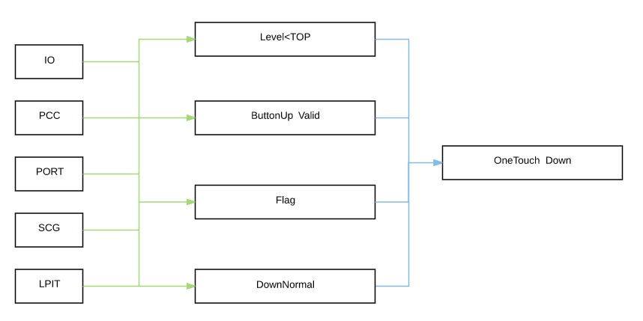

Antipinch
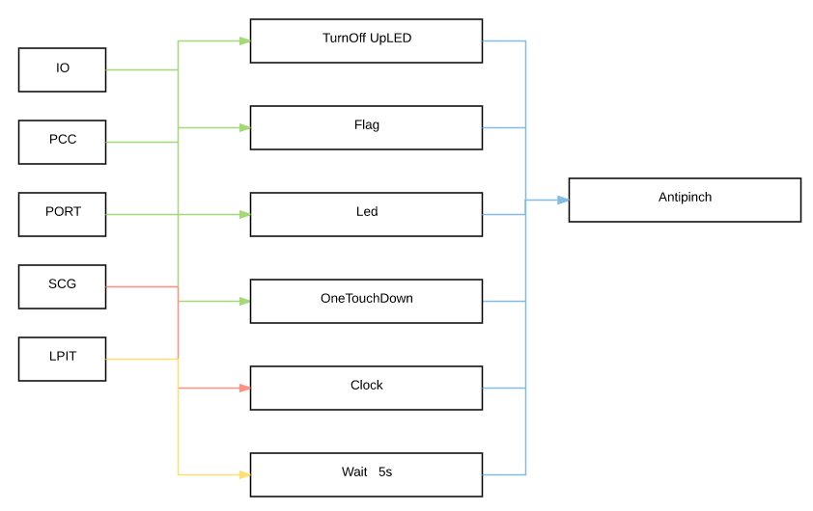

Functional Decomposition
Main function for the window lifter. Dependencies between main() and other functions in APP layer are shown in the following diagram.

Main function descomposition at APP level
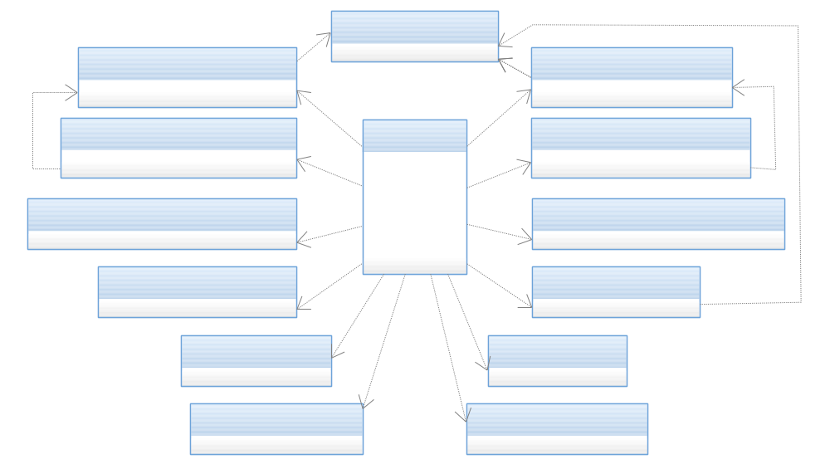

Main function descomposition at APP and HAL level

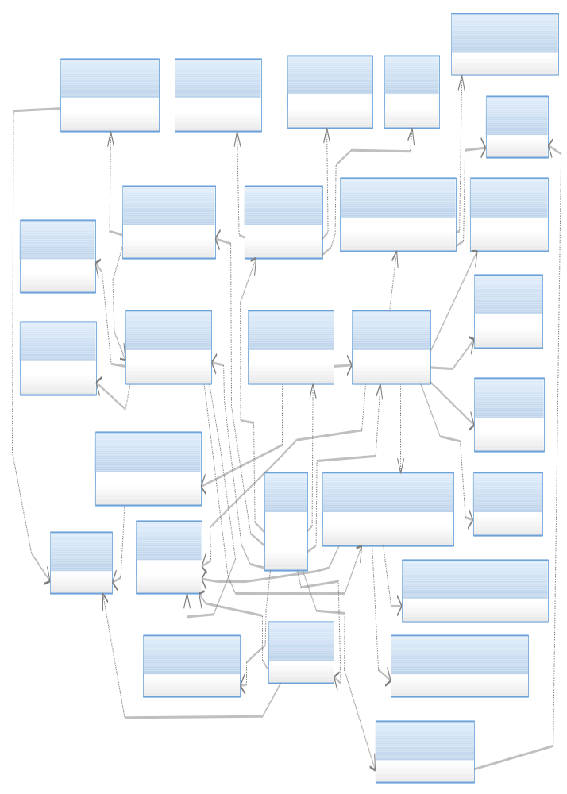

Window Lifter Flow Diagram

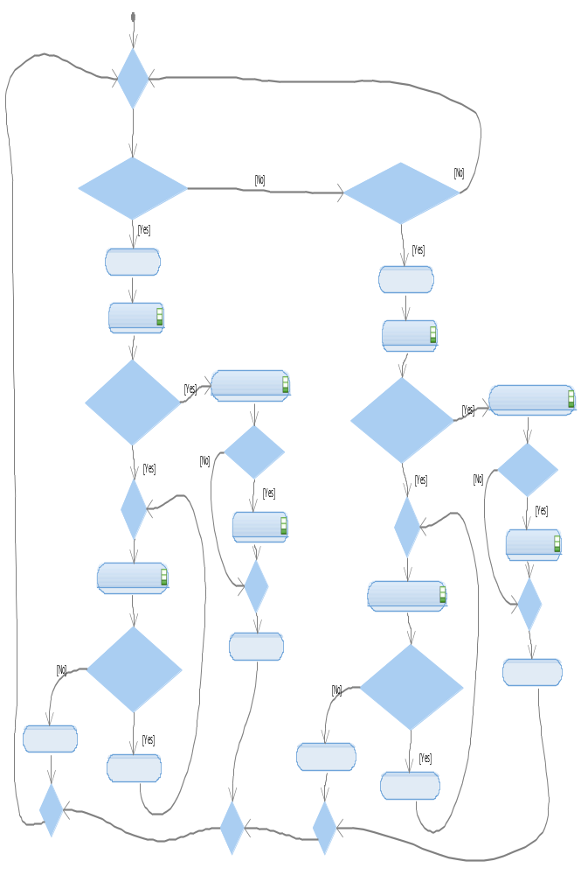

Function Description and Dynamic Behavior

HAL

Button.c

Function Void button_InitButtons(void)

Description | This function enables the specific pins in the ports to make them inputs, this are going represent the three button actions (UpButton, DownButton, AntipinchButton)
Parameter 1 | There is not a parameter in this function.
Return Value | Returns void
Precondition | None preconditions, but the PCC.C .library must be include
Post condition | The pins now have the new register so then the buttons are functional.
Error Conditions | None

Dynamic Behavior
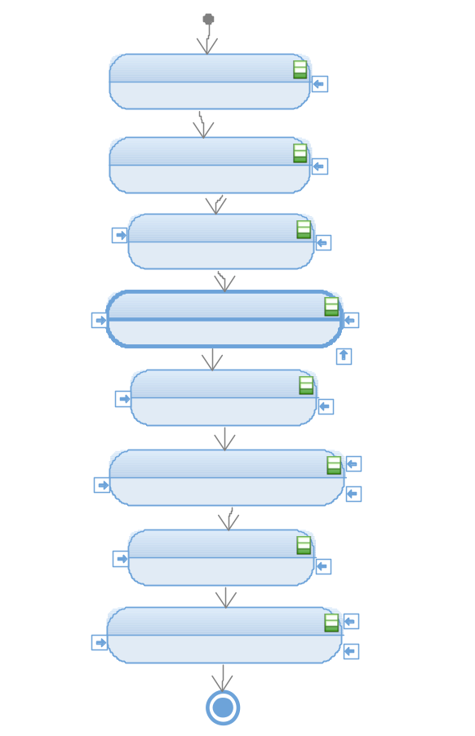

Function T_UBYTE button_CheckButtonUp(void)

Description | Checks the state of the Pin 5 of the Port E configured as input.
Parameter 1 | None
Return Value | Returns void
Precondition | The pin must have been configured as an input.
Post condition | The state (high 1 or low 0) should be returned.
Error Conditions | None

Dynamic Behavior
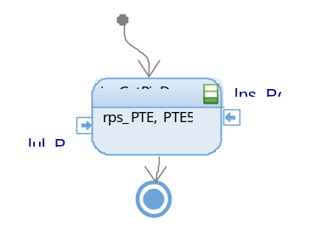

Function T_UBYTE button_CheckButtonDown(void)

Description | Checks the state of the Pin 12 of the Port A configured as input.
Parameter 1 | None
Return Value | Returns void
Precondition | The pin must have been configured as an input.
Post condition | The state (high 1 or low 0) should be returned.
Error Conditions | None

Dynamic Behavior
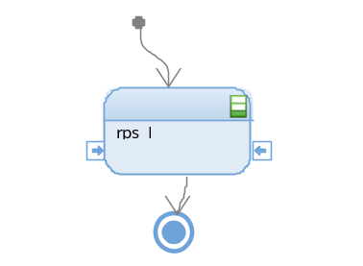

Function T_UBYTE button_CheckButtonAntipinch (void)

Description | Checks the state of the Pin 13 of the Port A configured as input.
Parameter 1 | None
Return Value | Returns void
Precondition | The pin must have been configured as an input.
Post condition | The state (high 1 or low 0) should be returned.
Error Conditions | None

Dynamic Behavior
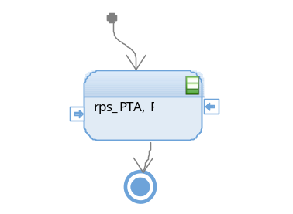

Function T_UBYTE button_DebounceButtonUp (void)

Description | Reads the input of the Up button, then waits 50ms and then reads it once again to be sure that it is a valid press ant not a debounce.
Parameter 1 | None
Return Value | Returns void
Precondition | The pin must have been configured as an input.
Post condition | Returns 1 if the press is valid and 0 if it is not valid.
Error Conditions | None

Dynamic Behavior
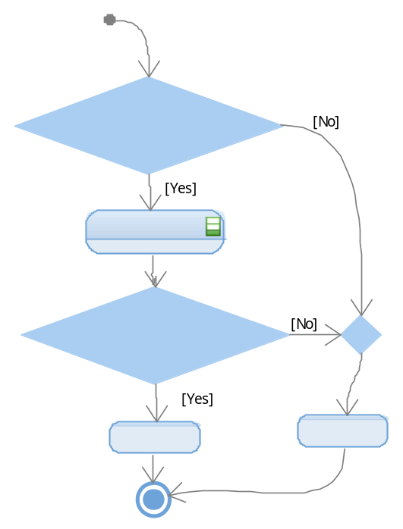

Function T_UBYTE button_DebounceButtonDown (void);

Description | Reads the input of the Down button, then waits 50ms and then reads it once again to be sure that it is a valid press ant not a debounce.
Parameter 1 | None
Return Value | Returns void
Precondition | The pin must have been configured as an input.
Post condition | Returns 1 if the press is valid and 0 if it is not valid.
Error Conditions | None

Dynamic Behavior

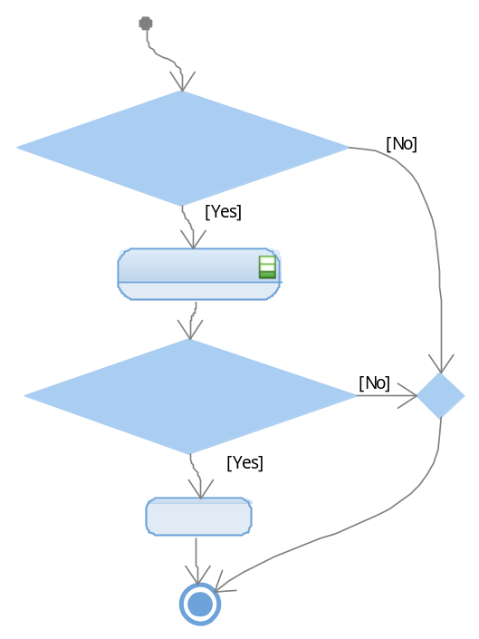

Function T_UBYTE button_DebounceButtonAntipinch (void);

Description | Reads the input of the Antipinch button, then waits 50ms and then reads it once again to be sure that it is a valid press ant not a debounce.
Parameter 1 | None
Return Value | Returns void
Precondition | The pin must have been configured as an input.
Post condition | Returns 1 if the press is valid and 0 if it is not valid.
Error Conditions | None

Dynamic Behavior

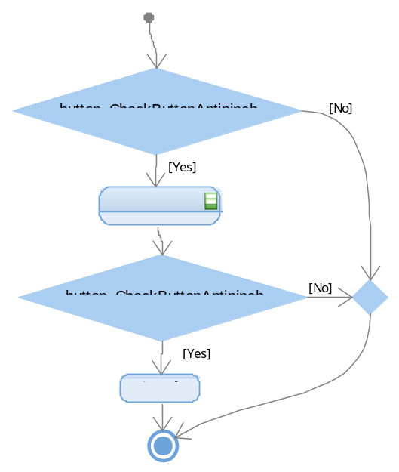

Clock

Function void clock_InitClock (void);
Description | Initializes the System Clock, the PLL and configures the Run mode of the system oscillator.
Parameter 1 | None
Return Value | Returns void
Precondition | None
Post condition | The system clock is initialized.
Error Conditions | None

Dynamic Behavior
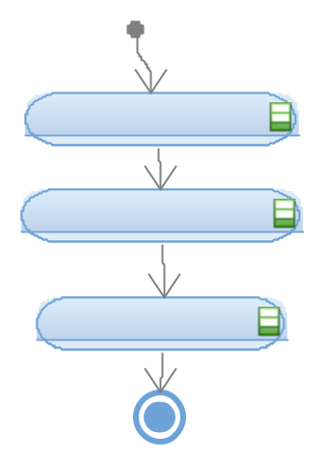

Leds

Function void leds_InitLeds(void);

Description | Configures the Pin 13 of the PortA (Up LED), the Pin 5 of the PortE (Down LED)Down and the Pin 12 of the PortA (Antipinch LED) as outputs.
Parameter 1 | None
Return Value | Returns void
Precondition | The clock of the Port A and E should have been initialized.
Post condition | The outputs of those pins are set low.
Error Conditions | None

Dynamic Behavior

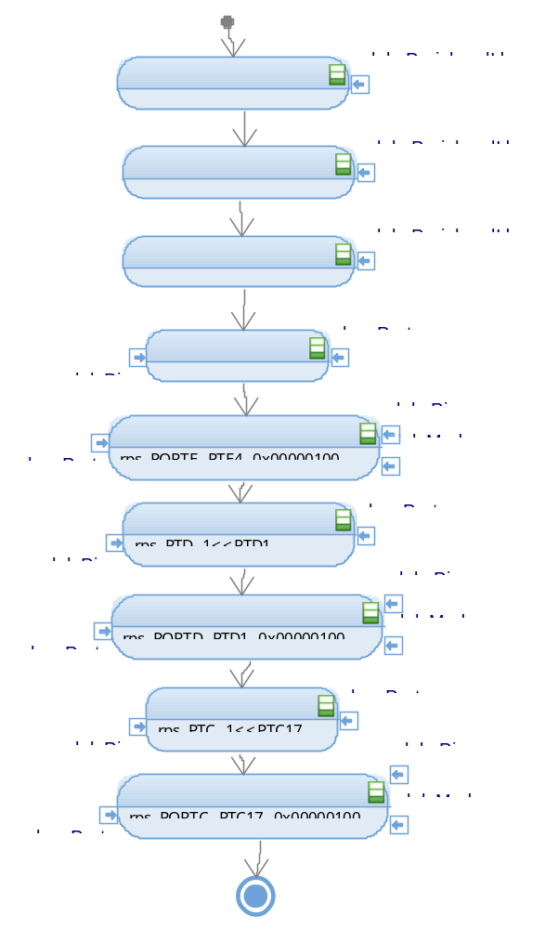

Function void leds_TurnOnUpLed (void);
Description | Sets high the output of the Up LED located at Pin 4 of the PortE
Parameter 1 | None
Return Value | Returns void
Precondition | The Pin should have been initialized as an output
Post condition | There is a high voltage level at the pin.
Error Conditions | None

Dynamic Behavior
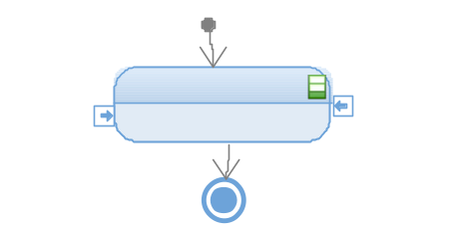

Function void leds_TurnOnDownLed (void)

Description | Sets high the output of the Up LED located at Pin1 of the PortD
Parameter 1 | None
Return Value | Returns void
Precondition | The Pin should have been initialized as an output
Post condition | There is a high voltage level at the pin.
Error Conditions | None

Dynamic Behavior
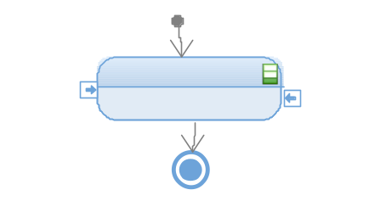

Function void leds_TurnOnAntipinchLed (void);

Description | Sets high the output of the Up LED located at Pin17 of the PortC
Parameter 1 | None
Return Value | Returns void
Precondition | The Pin should have been initialized as an output
Post condition | There is a high voltage level at the pin.
Error Conditions | None

Dynamic Behavior
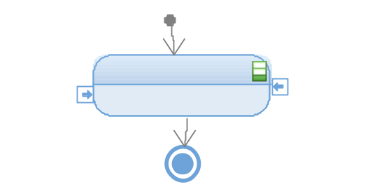

Function void leds_TurnOffUpLed (void)
Description | Sets low the output of the Up LED located at Pin17 of the PortC
Parameter 1 | None
Return Value | Returns void
Precondition | The Pin should have been initialized as an output
Post condition | There is a low voltage level at the pin.
Error Conditions | None

Dynamic Behavior
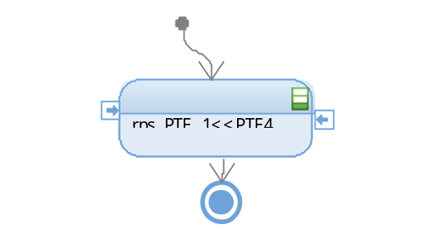

Function void leds_TurnOffDownLed (void)

Description | Sets low the output of the Up LED located at Pin1 of the PortD
Parameter 1 | None
Return Value | Returns void
Precondition | The Pin should have been initialized as an output
Post condition | There is a low voltage level at the pin.
Error Conditions | None

Dynamic Behavior

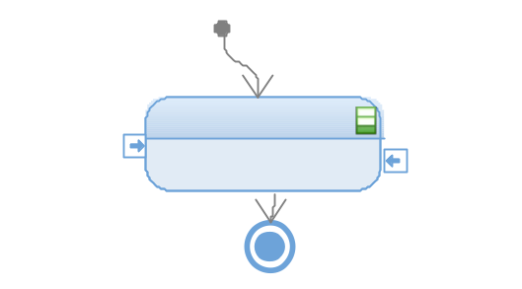

Function void leds_TurnOffAntipinchLed (void)

Description | Sets high the output of the Up LED located at Pin17 of the PortC
Parameter 1 | None
Return Value | Returns void
Precondition | The Pin should have been initialized as an output
Post condition | There is a high voltage level at the pin.
Error Conditions | None

Dynamic Behavior
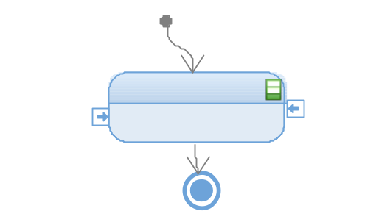

Segmentbar

Function void segmentbar_InitBar (void)

Description | This function enable the peripheral clock in each port to activate de in and out of our system, it configure the port pin for the assignation to our 10 segment bar led.
Parameter 1 | Output configuration, an configure pin mode from our ram memory to the pointer
Parameter 2 | None
Return Value | Returns void
Precondition | MCAL all functions active.
Post condition | Set level bar active to can active the local variable when the clear output is active or the set clear.
Error Conditions | None

Dynamic Behavior
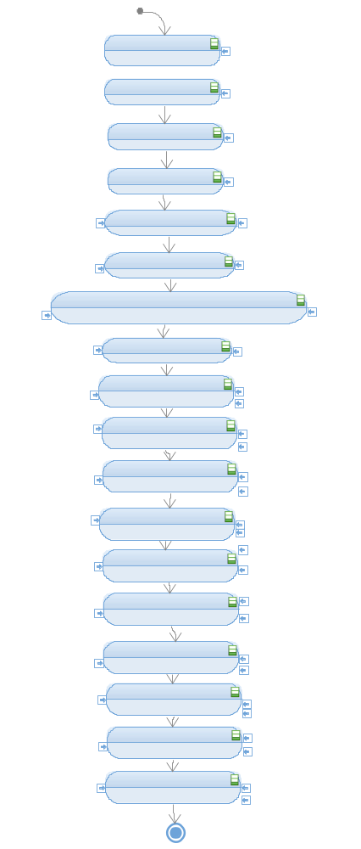

Function void segment_SetLevelBar (T_UBYTE lub_level, T_UBYTE lub_UpFlagInd,T_UBYTE lub_DownFlagInd)

Description | Turns on or off the segments of the segment bar depending on the level. It represents the window, it enables and disables each segment.
Parameter 1 | T_UBYTE lub_level, indicates the level of the windows that should be reached.
Parameter 2
Parameter 3
Return Value | Returns void
Precondition | The segment bar should have been initialized.
Post condition | The new level of the window is indicates through the segment bar.
Error Conditions | None

Dynamic Behavior
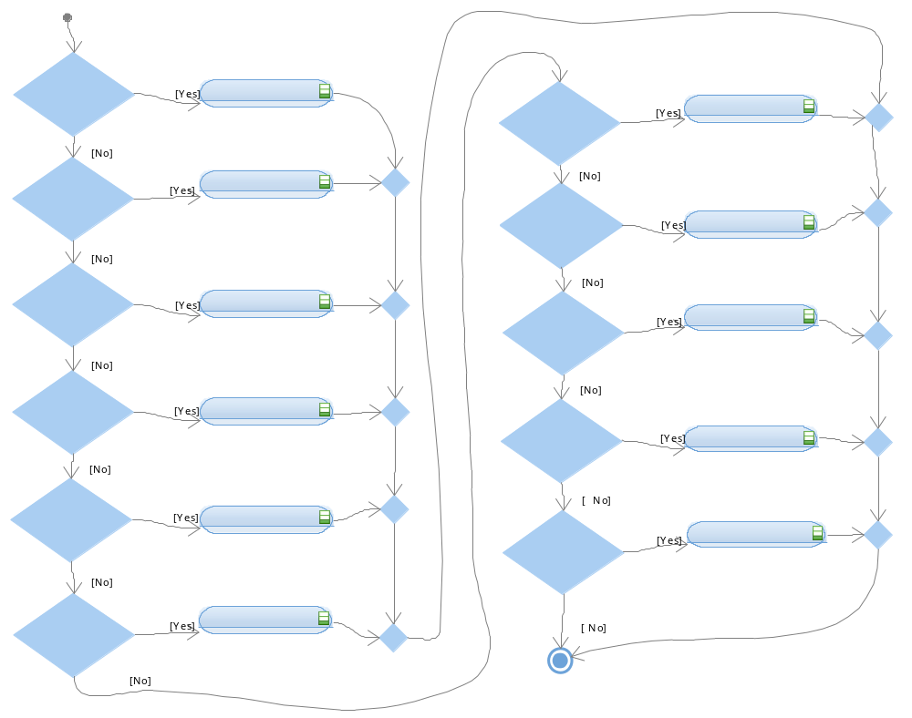

Function segmentbar_SetLevel10(T_UBYTE lub_UpFlagInd)

Description
Parameter 1
Return Value
Precondition
Post condition
Error Conditions

Dynamic Behavior

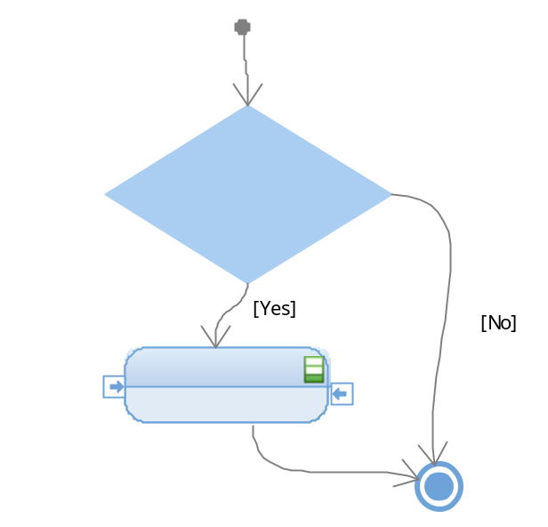

Function void segmentbar_SetLevel9(T_UBYTE lub_UpFlagInd, T_UBYTE lub_DownFlagInd)

Description
Parameter 1
Parameter 2
Return Value
Precondition
Post condition
Error Conditions

Dynamic Behavior
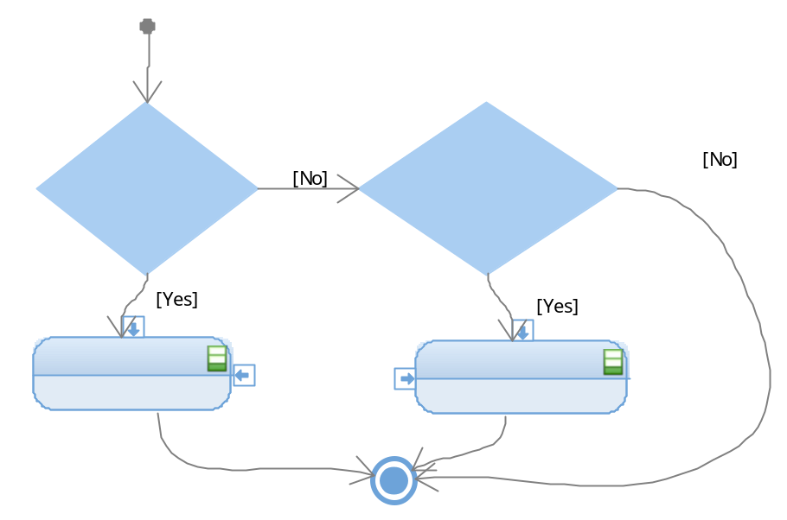

Function void segmentbar_SetLevel8(T_UBYTE lub_UpFlagInd, T_UBYTE lub_DownFlagInd)

Description
Parameter 1
Parameter 2
Return Value
Precondition
Post condition
Error Conditions

Dynamic Behavior
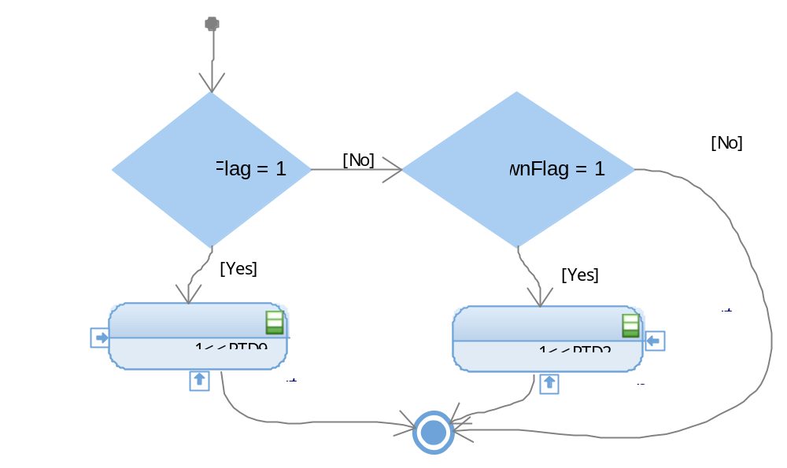

Function void segmentbar_SetLevel7(T_UBYTE lub_UpFlagInd, T_UBYTE lub_DownFlagInd)

Description
Parameter 1
Parameter 2
Return Value
Precondition
Post condition
Error Conditions

Dynamic Behavior
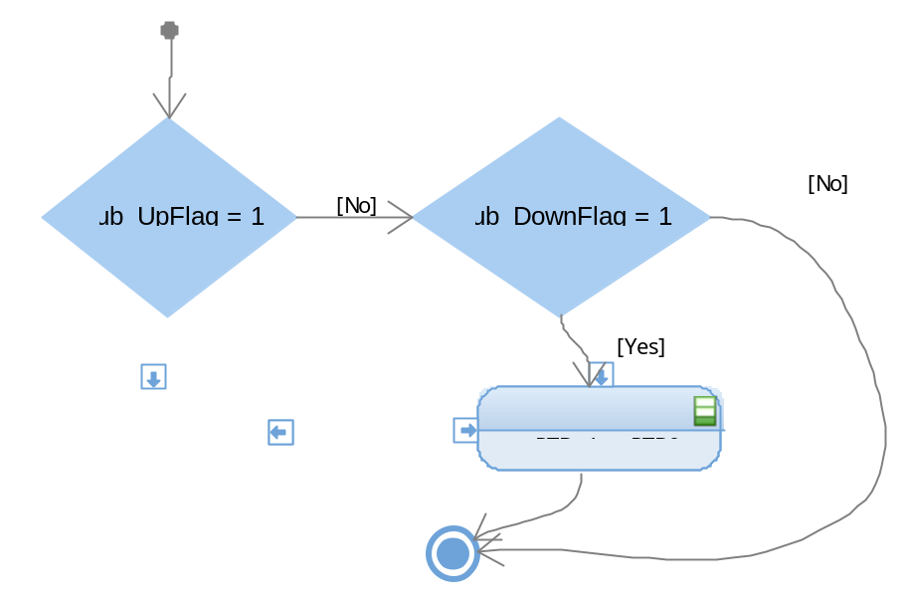

Function void segmentbar_SetLevel6(T_UBYTE lub_UpFlagInd, T_UBYTE lub_DownFlagInd)

Description
Parameter 1
Parameter 2
Return Value
Precondition
Post condition
Error Conditions

Dynamic Behavior

Function void segmentbar_SetLevel5(T_UBYTE lub_UpFlagInd, T_UBYTE lub_DownFlagInd)

Description
Parameter 1
Parameter 2
Return Value
Precondition
Post condition
Error Conditions

Dynamic Behavior
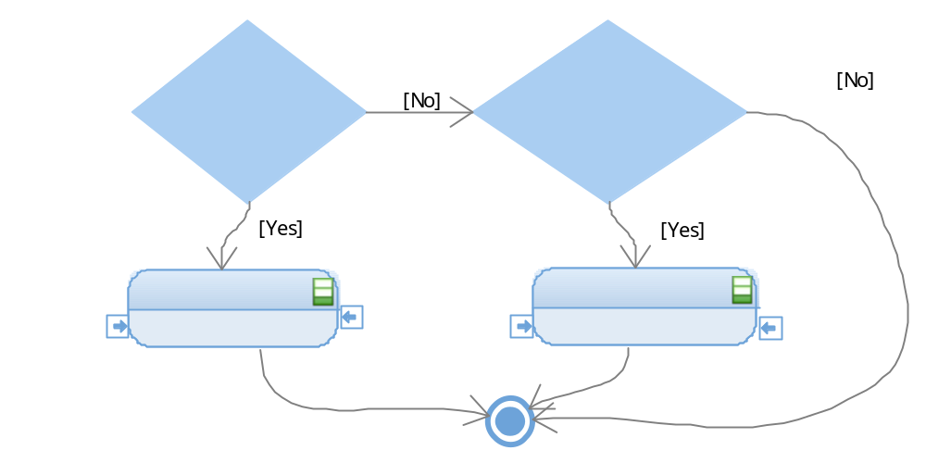

Function void segmentbar_SetLevel4(T_UBYTE lub_UpFlagInd, T_UBYTE lub_DownFlagInd)

Description
Parameter 1
Parameter 2
Return Value
Precondition
Post condition
Error Conditions

Dynamic Behavior
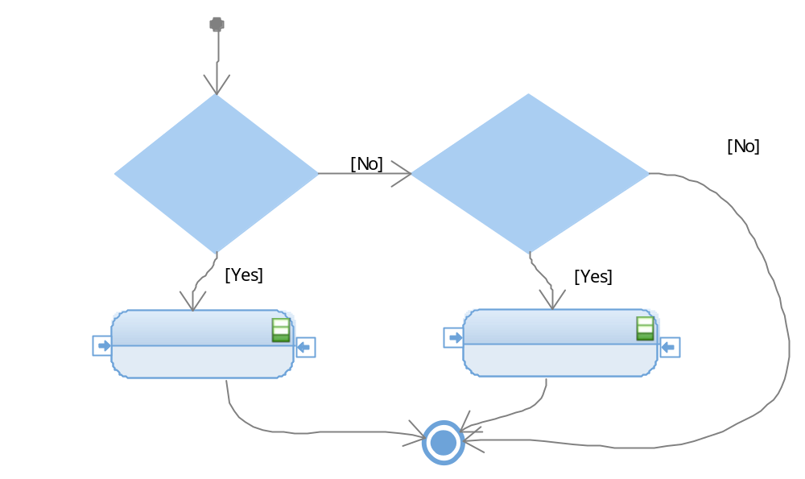

Function void segmentbar_SetLevel3(T_UBYTE lub_UpFlagInd, T_UBYTE lub_DownFlagInd)

Description
Parameter 1
Parameter 2
Return Value
Precondition
Post condition
Error Conditions

Dynamic Behavior
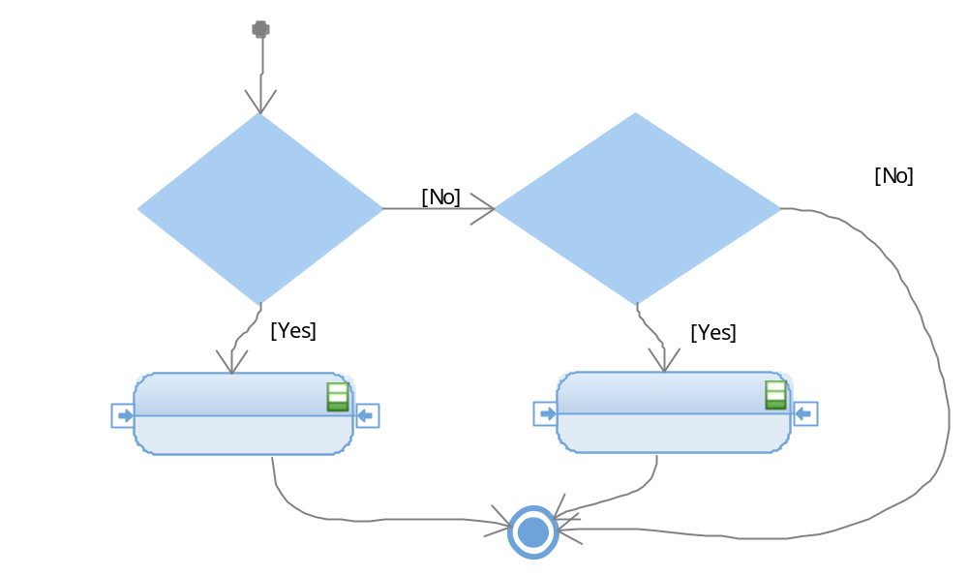

Function void segmentbar_SetLevel2(T_UBYTE lub_UpFlagInd, T_UBYTE lub_DownFlagInd)

Description
Parameter 1
Parameter 2
Return Value
Precondition
Post condition
Error Conditions

Dynamic Behavior
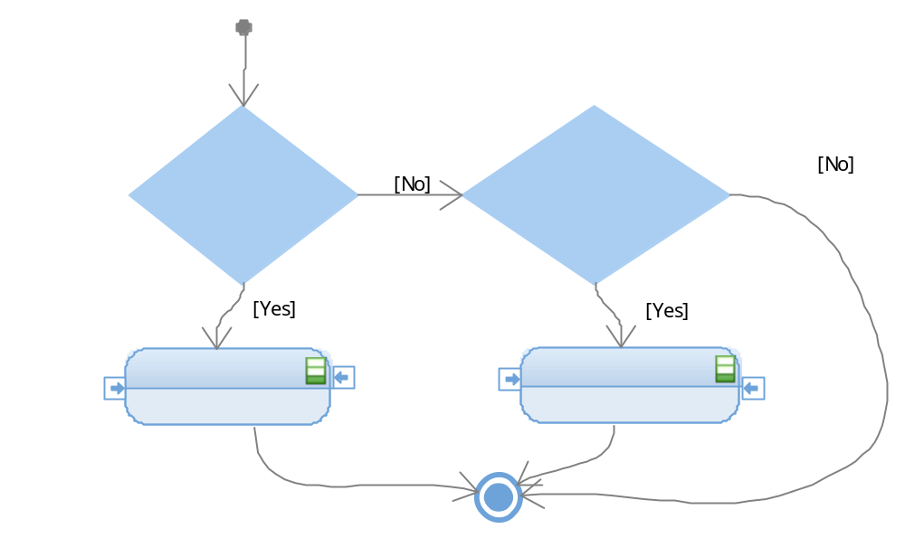

Function void segmentbar_SetLevel1(T_UBYTE lub_UpFlagInd, T_UBYTE lub_DownFlagInd)

Description
Parameter 1
Parameter 2
Return Value
Precondition
Post condition
Error Conditions

Dynamic Behavior
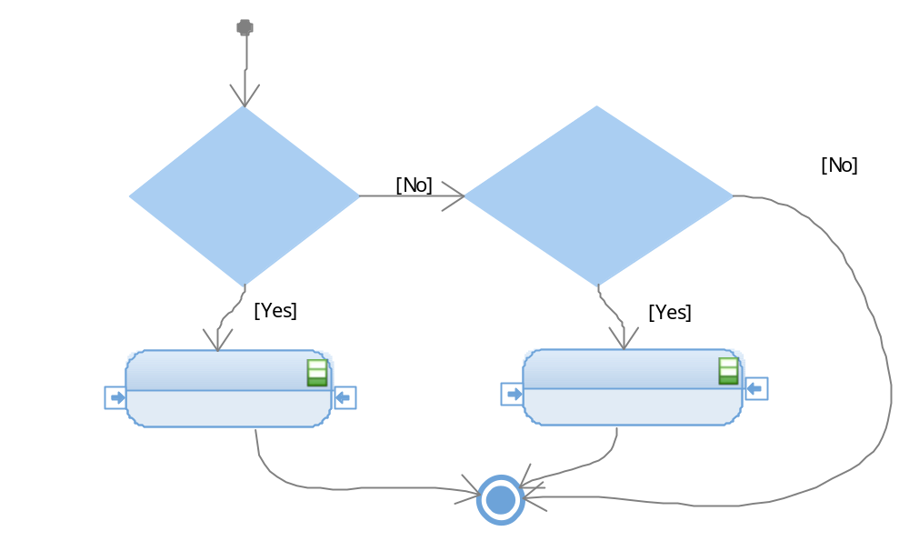

Function void segmentbar_SetLevel0(lub_DownFlagInd)

Description
Parameter 1
Return Value
Precondition
Post condition
Error Conditions

Dynamic Behavior
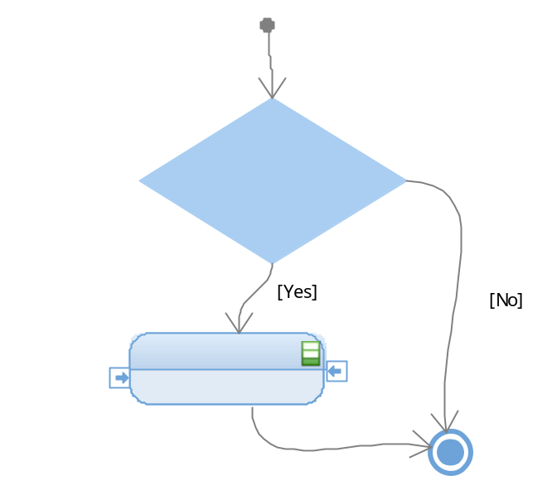

Timer

Timer

Function void timer_InitTimer (void)

Description | This functions makes than the timer stars to run for our system
Parameter 1 | LPIT must be enable
Return Value | Returns void
Precondition | MCAL functions active
Post condition | The pins now have the new register so then they can act with some conditions.
Error Conditions | None

Dynamic Behavior
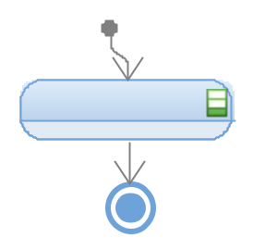

Function void timer_Wait50ms (void)

Description | This function delays the time to approximately 50 milliseconds. Uses the channel 0 of the LPIT to implement the delay. Charges the delay value, enables the timer and wait until it completes the count, then clean the interrupt flag and disable the timer.
Parameter 1 | When the LPIT is enable
Return Value | Returns void
Precondition | MCAL all function active.
Post condition | None
Error Conditions | None

Dynamic Behavior
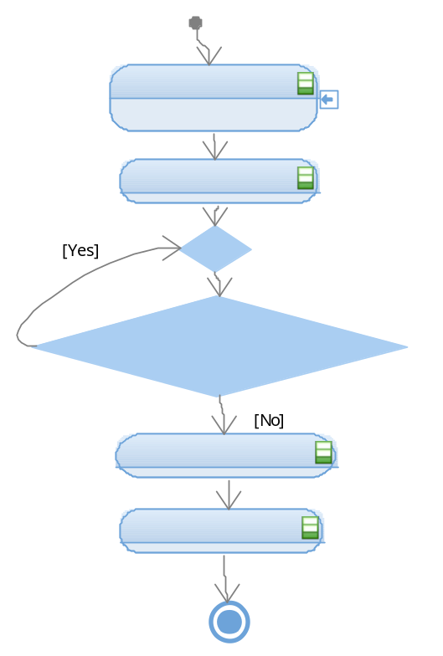

Function void timer_Wait400ms (void)
Description | This function delays the time to approximately 400 milliseconds. Uses the channel 0 of the LPIT to implement the delay. Charges the delay value, enables the timer and wait until it completes the count, then clean the interrupt flag and disable the timer.
Parameter 1 | None
Return Value | Returns void
Precondition | MCAL all function active.
Post condition | None
Error Conditions | None

Dynamic Behavior
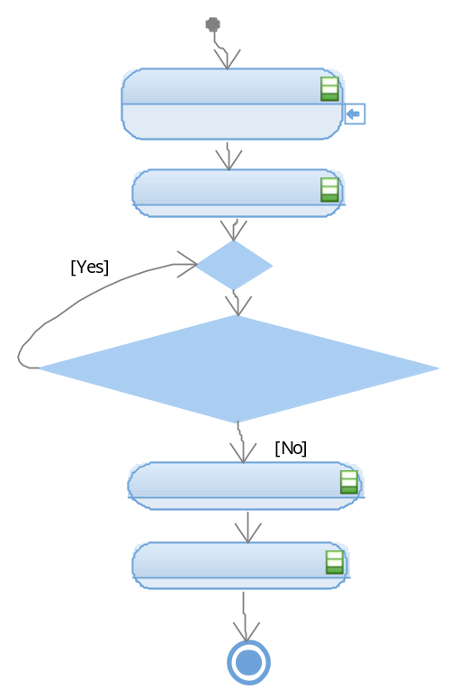

Function void timer_Wait450ms(void)

Description | This function delays the time to approximately 450 milliseconds. Uses the channel 0 of the LPIT to implement the delay. Charges the delay value, enables the timer and wait until it completes the count, then clean the interrupt flag and disable the timer.
Parameter 1 | None
Return Value | Returns void
Precondition | MCAL functions active.
Post condition | None
Error Conditions | None

Dynamic Behavior
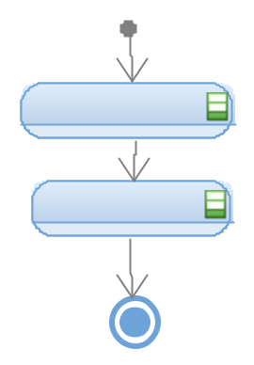

Function void timer_Wait5s (void)

Description | This function delays the time to approximately 5 seconds. Uses the channel 0 of the LPIT to implement the delay. Charges the delay value, enables the timer and wait until it completes the count, then clean the interrupt flag and disable the timer.
Parameter 1 | None
Return Value | Returns void
Precondition | MCAL all function active.
Post condition | Windowlifter.c: UpNormal, DownNormal, OneTouchUp, OneTouchDown, Antipinch
Error Conditions | None

Dynamic Behavior

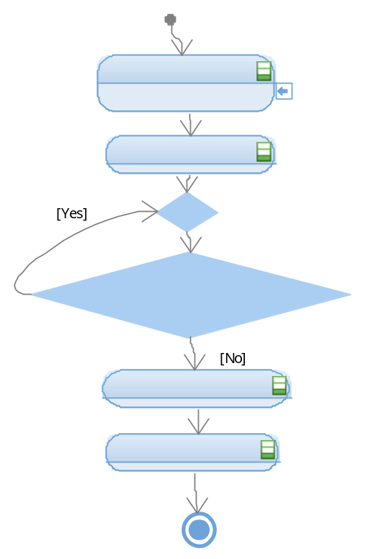

APP

Windowlifter

Function void windowlifter_Antipinch(void);

Description | In this function the action of the Antipinch button starts, this initialized the verification of the correct button and checks the exclusive Up movement of the window running.
Parameter 1 | None
Return Value | Returns void
Precondition | All the libraries of Hal, the buttons has to be initialized
Post condition | The system star the wait time of 5 seconds in the system to return to the origin and starts all the functions again.
Error Conditions | Pinch the button too late to be able to make the window down exclusively when the Up Normal is going.

Dynamic Behavior
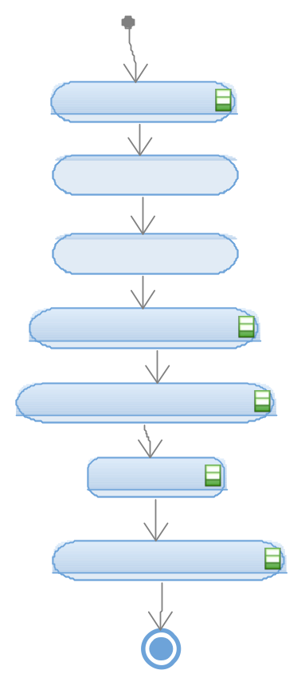

Function void windowlifter_UpNormal (void)

Description | The Up Normal activates the up movement or window, this is controlled for the time than our physical button is press, this function conducts a validation with the debounce antipinch button, if the other is running this functions is not going to have any result.
Parameter 1 | None
Return Value | Returns void
Precondition | The only precondition is not have the antipinch function running at the same time, this requires the HAL functions.
Post condition | The segment bar level on and waiting time.
Error Conditions | None

Dynamic Behavior
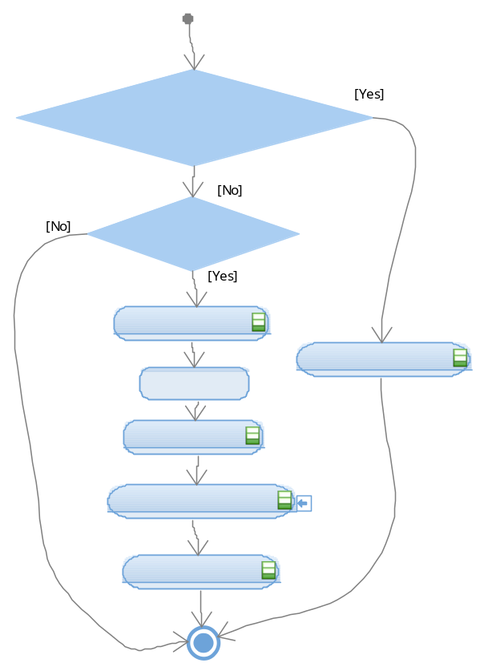

Function void windowlifter_DownNormal (void)
Description | The Down Normal activates the down movement for the window, this is controlled for the time than our physical button is press too, the function make a validation checking than the segment level bar have enough level to can work.
Parameter 1 | None
Return Value | Return Void
Precondition | Needs all the HAL functions, and the level of the segment bar shall to have a value.
Post condition | Time waiting of 450ms to make the function.
Error Conditions | None

Dynamic Behavior

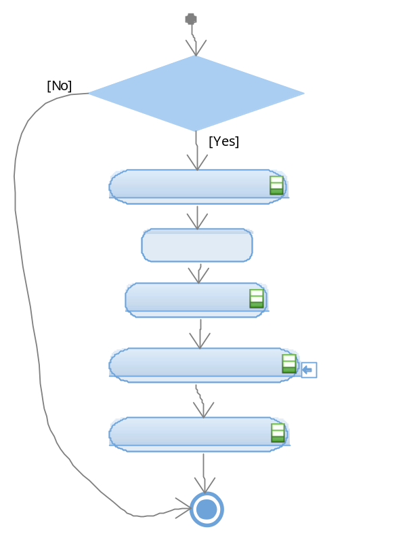

Funtion void windowlifter_OneTouchUp (void)
Description | This functions works with the same button of the Up movement, this function moves the window up one led to the time, until the level we wanted, the only condition is the validation of the not down button.
Parameter 1 | None
Return Value | Return void
Precondition | Antipinch function must not be operating and the level of segment bar should not be complete.
Post condition | The option to continue pressing the button and do the up movement till the level be equal to the top, all the other normal function of or system.
Error Conditions | Pressing for too short time and don’t be detected.

Dynamic Behavior

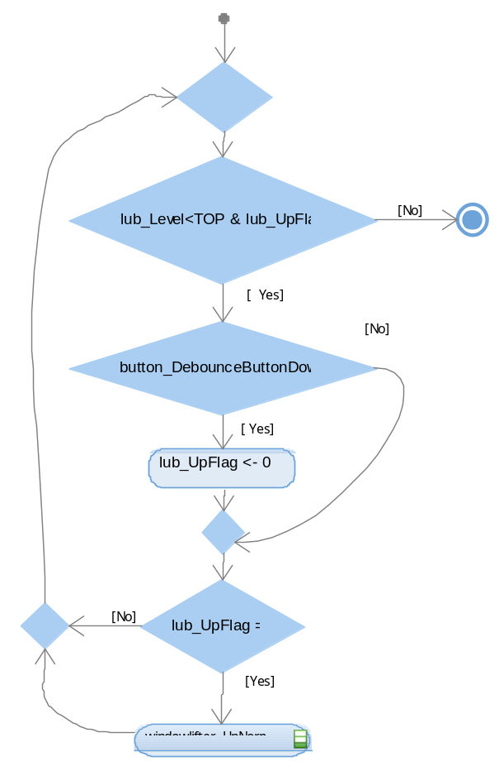

Function void windowlifter_OneTouchDown(void)
Description | This functions works with the same button of the Down movement, this function makes than the window will down one led to the time, until the level we wanted, the only condition is the validation of the not up button be press.
Parameter 1 | None
Return Value | Return void
Precondition | This only can operate when the down button is press and the time valid the operation. This function works with all the HAL include.
Post condition | The option to continue pressing the button and do the down movement till the level be equal to the bottom, all the other normal function of or system.
Error Conditions | Pressing for too short time and don’t be detected or starts to work when the antipinch is going to run.

Dynamic Behavior
